Copper Never in Furnace
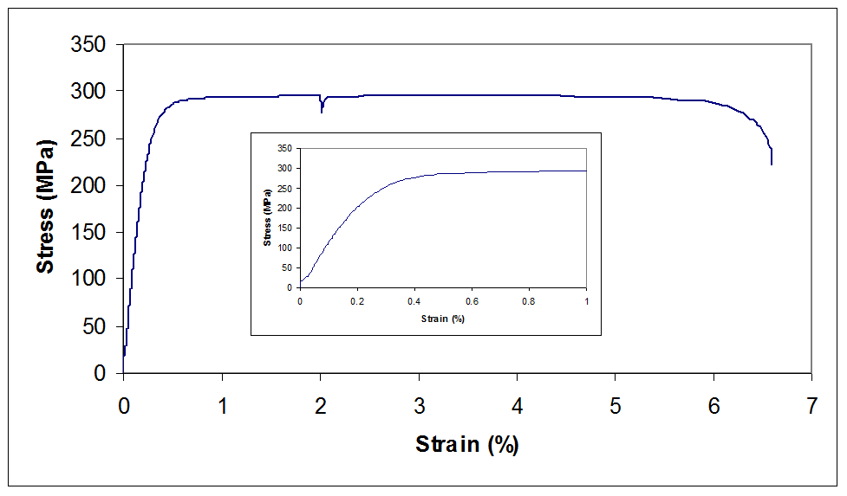

Copper in Furnace at 1250F for 1 hr
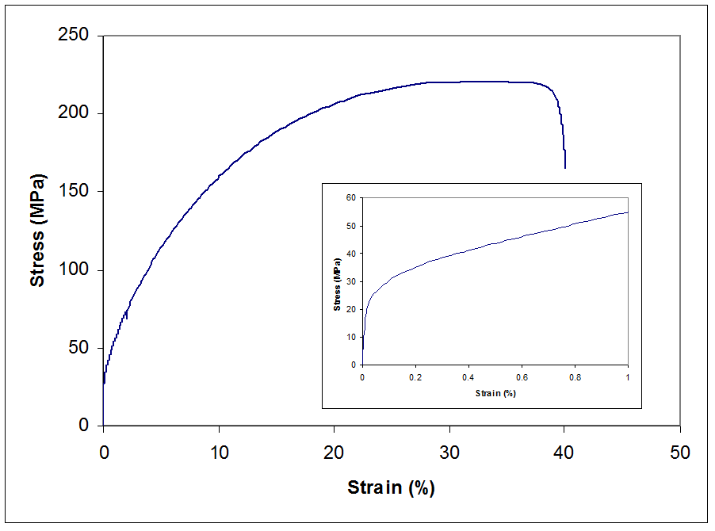

Copper in Furnace at 1650F for 1 hr
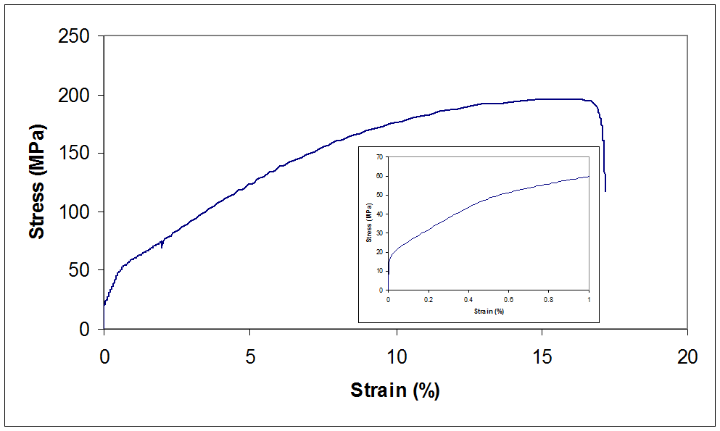

1050 Steel Never in Furnace
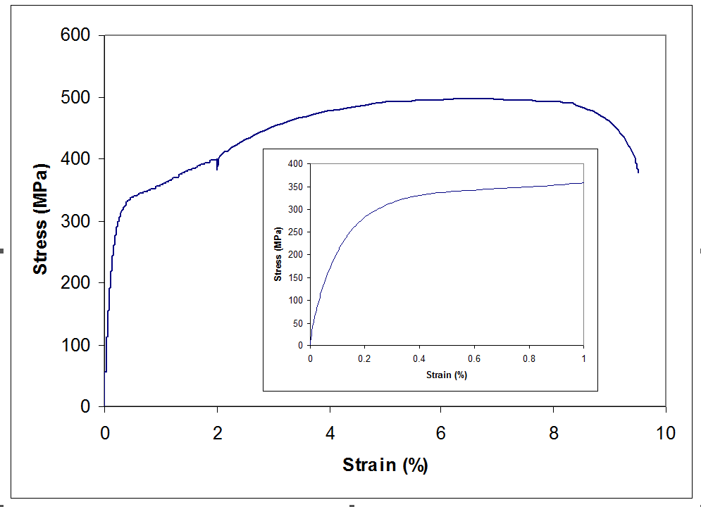
1050 Steel in Furnace at 1250F for 1 hr
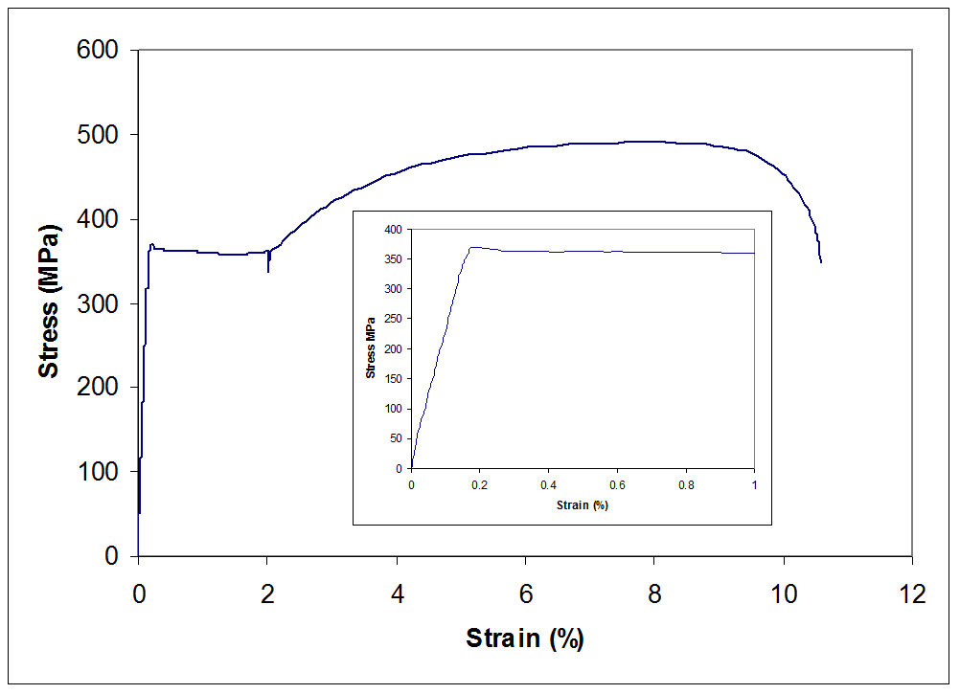

1050 Steel in Furnace at 1650F for 1 hr
